Robot Programming – Mapping

Overview:

- Mapping, SLAM in 2D/3D and laser/visual
- ROS concepts:map_Server, gmapping, octomap
Reference material:

- A module on robotic mapping:
https://www.youtube.com/playlist?list=PLgnQpQtFTOGQrZ4O5Qz
bIHgl3b1JHimN_
- ROS wiki: slam_gmapping

Mapping
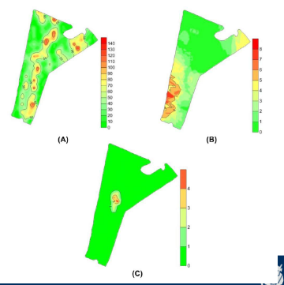
Maps are a collection of features at some scale of interest and a representation of spatial and semantic relationships among them.

Useful for many robotic tasks: localisation, navigatio, plannong and manipulation.

Maps for robot navigation: metric and topological
Maps with semantic meaning e.g. in agriculture: map of strawberry fruit, weeds, stress in plants.

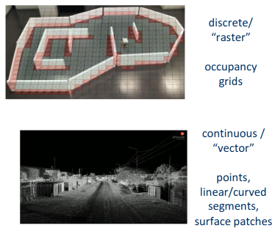
Metric Maps – Different Types

Location of objects in an absolute coordinate system.
Maps can be 2D (works for indoor UGVs) and full 3D (UAVs and UGVs in rough terrain)
Using 2D/3D lasers but also vision sensors: mono-, stereo- and RGBD (kinect-like)

2D Occupancy Maps
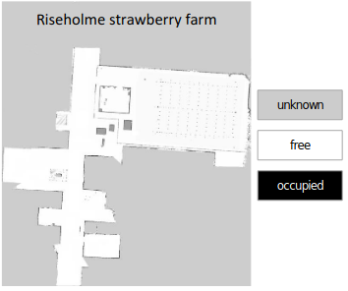
Represent the free and occupied parts of the environment – Occupancy Grid
Built from the 2D laser sensors, using the SLAM algorithm (e.g. gmapping)
Managed and provided by map_server

ROS Navigation Stack
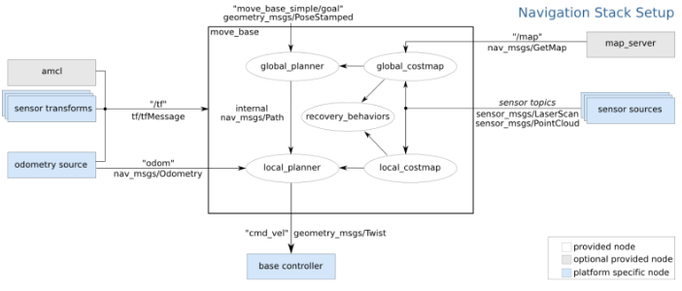
map_Server – Usage
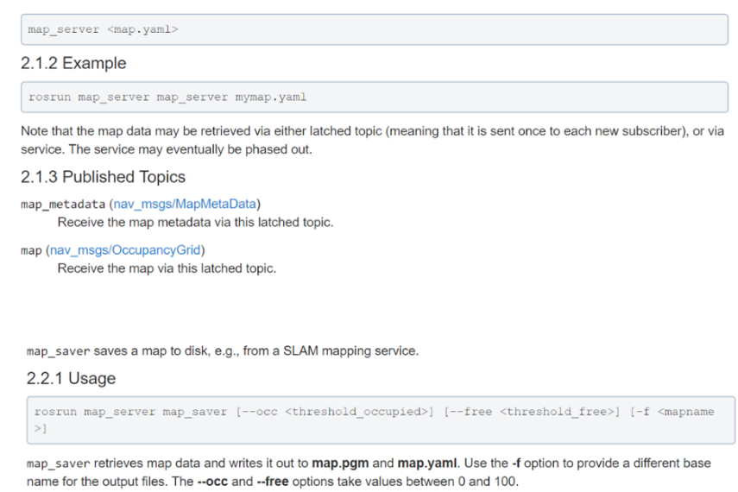

rosrun map_server map_server ‘rospack find map_folder_name’/mymap.yaml
rosrun map_server ,ap_server -f mymap

Local registration – rely on some motion model of the robot to predict where the robot will be in a later time step. Then we compare the position of the robot to the map that is being created. This tells us where the robot is and isn’t. This allows the robot to then localise itself as well.

